
K&M Tire

Tire Supply & Equipment
Version 1.0
03/17/2021

Document Number:
Contract Number:

Table of Contents
1. K&M Tire 1
1.1 Important Company Information 3
2. Tire Supply & Equipment BDM Introduction 4
3. Overview 5
3.1 Conventions 5
3.2 Cautions & Warnings 5
This manual does not supersede any safety or company policy 5
4. Tire Supply and Equipment Business Development Manager 6
4.1 Responsibilities / Duties 6
4.2 Meeting with vendors and being the contact personal for K&M Tire on the tire supply / equipment division 6
4.3 Negotiate pricing and contacts on all tire supplies and equipment that K&M Tire stocks and sells in all location. 7
4.4 Make sure the office manager of tire supply / equipment division has all current price files updated in Maddenco. 7
4.5 Setting margins of the stocking/drop ship tire supply/equipment. 7
4.6 Making sure all NSEQ/Drop ship items are being billed out and sent back in a timely fashion for A/P 8
4.7 Working with all vendors on monthly and quarterly specials. 8
4.8 Enhancing organization reputation by accepting ownership for accomplishing new and different opportunities on tire supplies / equipment items. 8
4.9 Providing training, leadership & direction to tire supplies / equipment team to produce maximum GP. 9
4.10 Keep outside sales staff updated with monthly sales flyers and promotions on tire supplies / equipment. 9
4.11 Submit monthly communication report to Admin Department, VP of Sales and Director of Sales. 9
4.12 Submit and approve time cards / PTO / Reviews for the tire supply division in Paylocity. 9
4.13 Work closely with K&M management 9
4.14 Must support company goals and playbook. 10
5. Frequently Asked Questions 12
6. Other 13
Appendix A: Miscellaneous 14
Appendix B: Supportive Department Summaries 15
Appendix C: Glossary 16
Appendix D: Referenced Documents 17
Appendix E: Approvals 19
Appendix F: Additional Appendices 20
Appendix G: Notes to the Author/Template Instructions 21
Appendix H: Revision History Tracking 22

- List of Figures
No table of figures entries found.

- List of Tables
Table 1 - Support Points of Contact 115
Table 2 - Acronyms 119
Table 3 - Glossary 121
Table 4 - Referenced Documents 122
Table 5 - Approvals 124
Table 6 - Revision History Tracking 127

K&M Tire
Video about K&M Tire
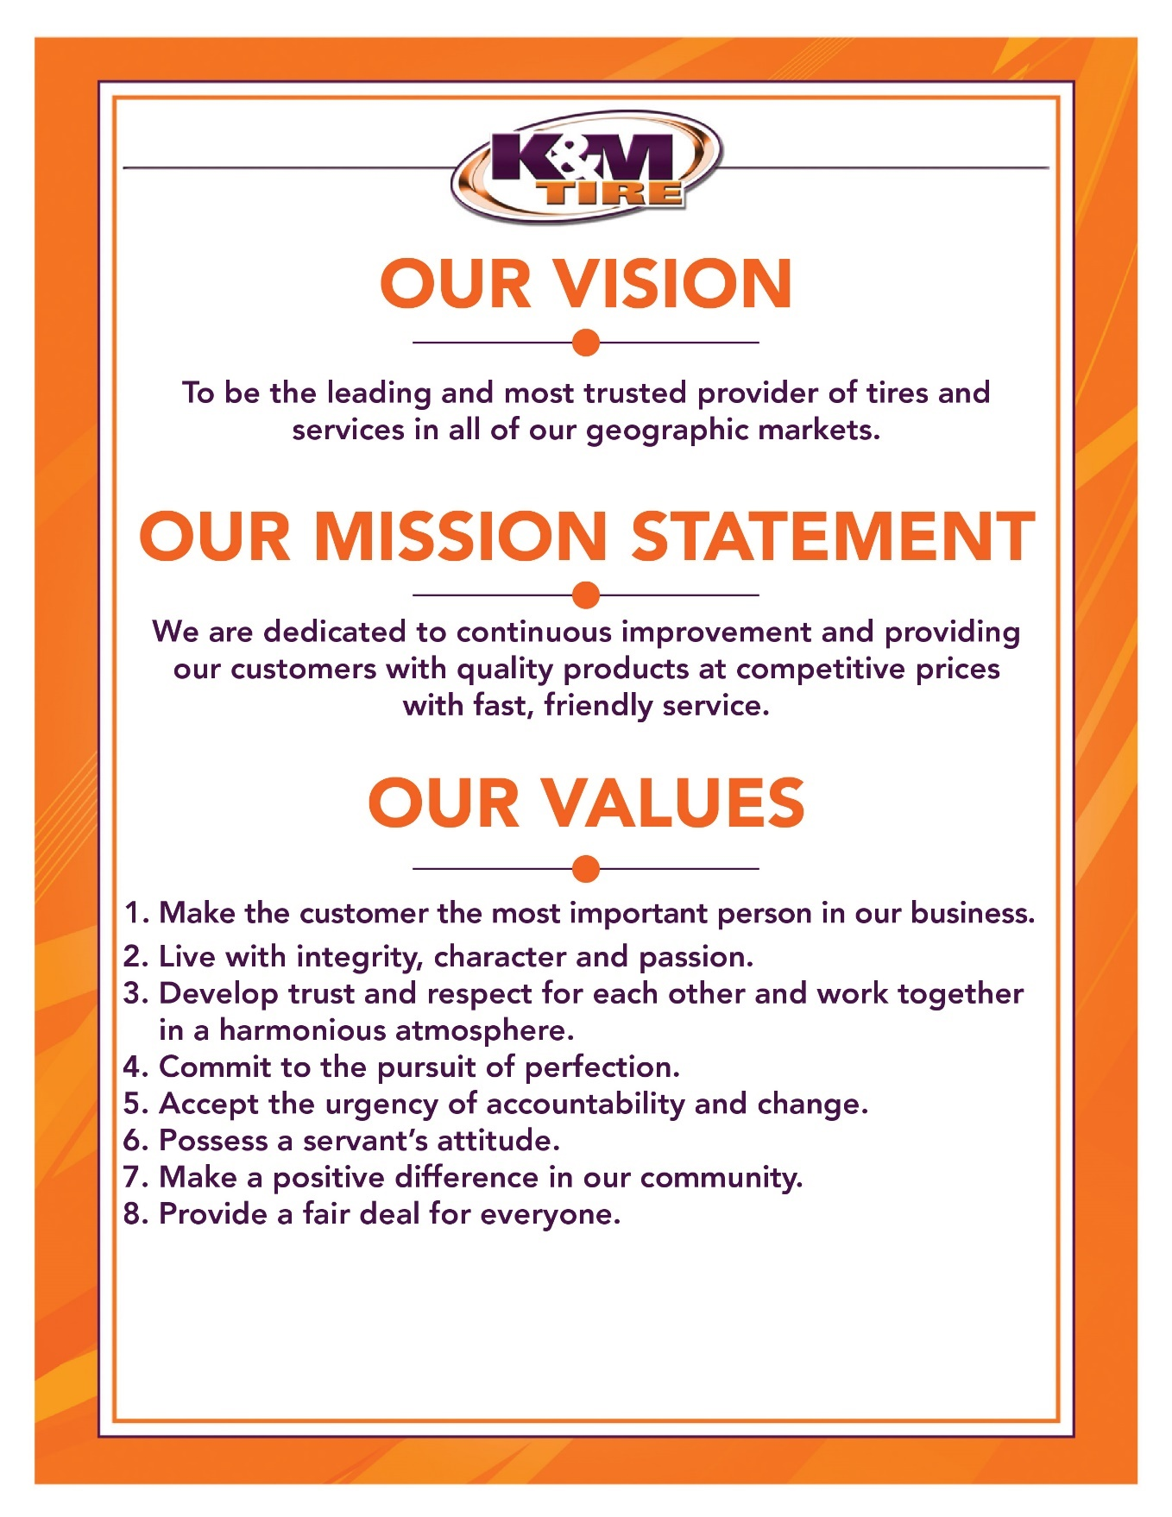

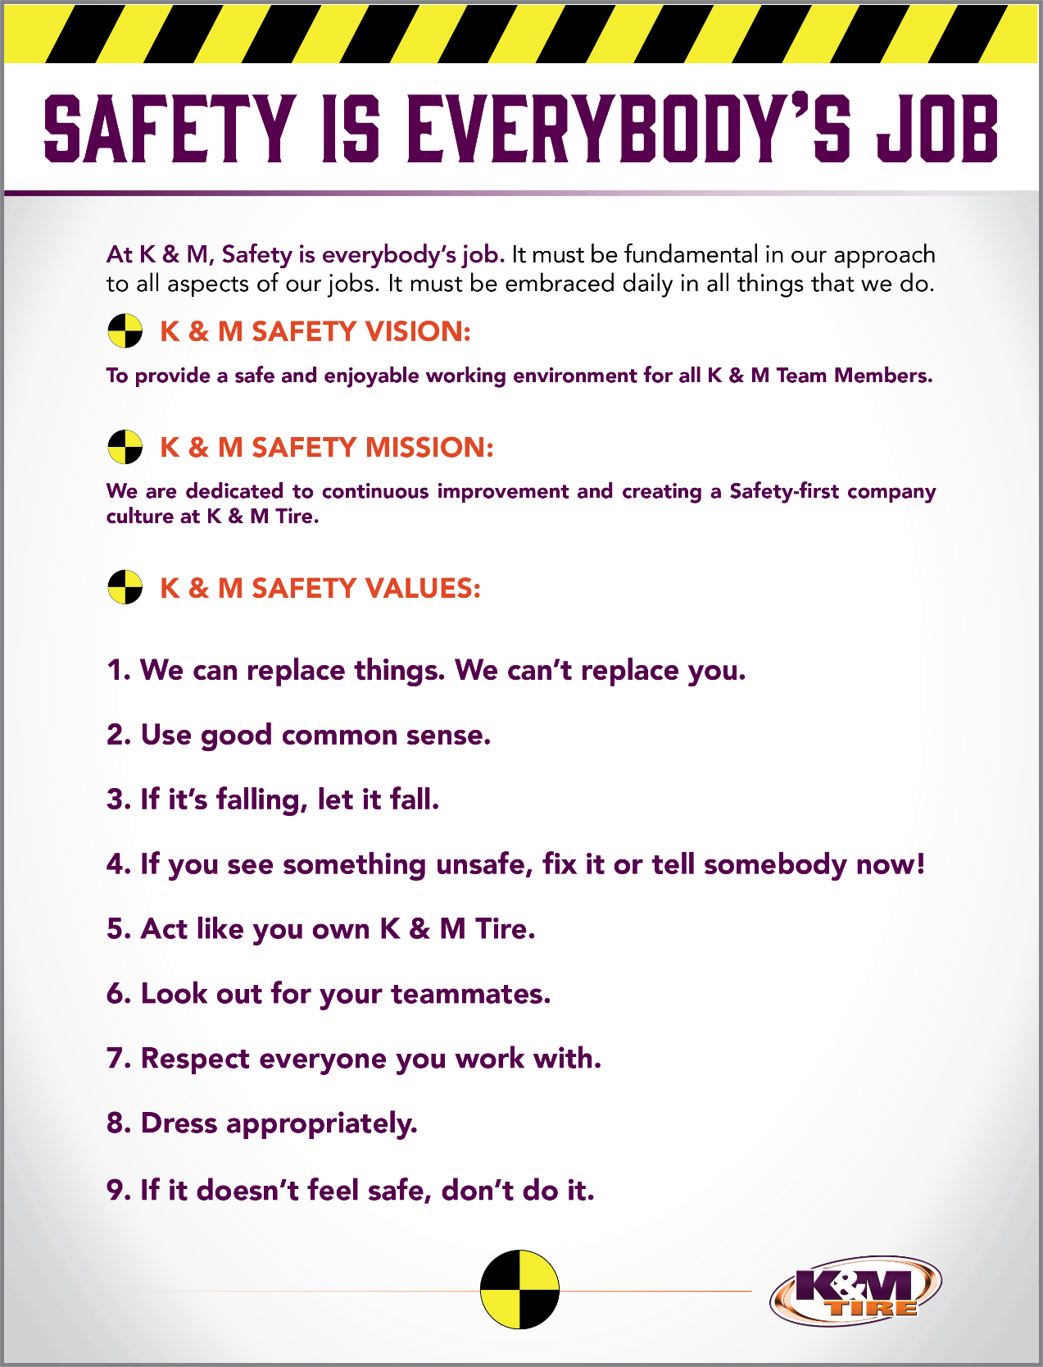

Important Company Information
This information is updated frequently. To ensure you are viewing the most current and accurate information, please use the links to access each document.

Employee Handbook
Employee Handbook can be found in Paylocity under Self – Service Portal then unemployment and is accessible HERE.

Organizational Chart
The organizational chart is a breakdown showing who is on each team and the chain of command throughout the entire company starting with the CEO and President. It is maintained on Paylocity and is accessible HERE.

Our Locations:

Warehouse Locations - Contact Information
The Warehouse Locations – Contact Information is a Word document listing each of our warehouse locations’ addresses, a phone number to reach the warehouse/manager, the manager’s name and an email address for to reach the warehouse manager directly as well as a “location” email. When sending an email to the location email address, it will be sent to anyone associated with that warehouse who has an active email address. This list is maintained by our Human Resources department and can be found on the F: Drive. You can also view the list by clicking HERE.

K&M Tire US Footprint
Click on the below link to see the footprint map
http://kmtire.com/km-cgi/distmap

Tire Supply & Equipment BDM Introduction

This manual is intended to provide helpful information for any person working in the Tire Supply & Equipment positions with K&M Tire. It will be especially helpful for those newly hired or new to Tire Supply & Equipment BDM position. There will be some step by step procedural suggestions. This manual, however, does not replace the necessity to work closely with the VP of Sales for guidance when needed.

Overview
Welcome to the K&M Tire family and Tire Supply & Equipment Team! We are pleased you decided to become part of our positive culture and strive to make our company the leading and most trusted tire distributor. Our #1 Value is to make the customer the most important person in our business, and that starts with you. We have many tools to help you along the way and we understand that it can be overwhelming in the beginning. Do not hesitate to ask for help; like family we are all here to support you.
It would be impossible to include everything in such a short letter. For this reason, we created this S.O.P. (Standard Operating Procedure) reference guide. We will keep this up to date when processes change, but remember if you have any questions, ASK. Welcome to the team and we look forward to sharing your success!

Conventions
This document provides screen prints and corresponding narrative to describe how to use the Maddenco, Weblink and K&M Intranet, known as “company systems”
Note: The term ‘user’ is used throughout this document to refer to a person who requires and/or has acquired access to the company systems.

Cautions & Warnings

This manual does not supersede any safety or company policy

Tire Supply and Equipment Business Development Manager

Responsibilities / Duties
- Meeting with vendors and being the contact personal for K&M Tire on the tire supply/equipment division.
- Negotiate pricing and contracts on all tire supplies and equipment. That K&M Tire stocks and sells in all locations.
- Making sure the office manager of the tire supply/equipment division has all current pricing files for ordering.
- Review and approve stocking orders on big equipment vendors. This does not included tire supply inventory.
- Setting margins of the stocking/drop ship tire supply/equipment.
- Making sure all NSEQ/Drop ship items are being billed out and sent back in a timely fashion for A/P.
- Working with all vendors on monthly and quarterly specials.
- Enhance organization reputation by accepting ownership for accomplishing new and different opportunities on tire supplies/equipment items.
- Provide training, leadership & direction to tire supply/equipment team to produce maximum GP.
- Keep outside sale staff updated with monthly sales flyers and promotions on tire supplies/equipment.
- Submit monthly communication report to Admin department, VP of Sales and Director of Sales.
- Submit and approve time cards/PTO/Reviews for the tire supply division in paylocity.
- Work closely with K&M management.
- Must support company goals/playbook.

Meeting with vendors and being the contact personal for K&M Tire on the tire supply / equipment division
- Vendor# 254 31 Inc.- Contact: Jerry/Tracy Friddle PH#800-438-3302 email: jfriddle@31inc.com / tfriddle@31inc.com Stocking Vendor
- Vendor# 252 AME- Contact: Rick Engley Ph#877-755-4263 email: rengley@ameintl.net Stocking Vendor
- Vendor# 261 Castair- Contact: Rick/Pat Kelly Ph#320-796-0851 email: castair@tds.net special order non-stocking
- Vendor# 277 Centramatic- Contact: C Benton email: cbenton@centramatic.com Stocking Vendor
- Vendor# 262 Challenger Lifts- Contact: Don Glaser Ph#847-975-7358 email: dglaser@challengerlifts.com Stocking Vendor parts only
- Vendor# 264 Delegard Tool- Contact: Jim Boman Ph#800-328-2897 email: jboman@delegardtool.com special order non-stocking
- Vendor# 284 Dell Corning- Contact: David Pate Ph#864-578-5552 email: gwalker@rhdowning.com Stocking Vendor
- Vendor# 275 ESCO- Contact: Paul Dyer Ph#352-754-1735 email: pdyer@esco.net Stocking Vendor
- Vendor#372 Hennessy/Coats- Contact: Bob Kimes Ph#267-269-1227 email: bob.kimes@ammcoats.com Stocking Vendor
- Vendor#390 Hunter National Acct- Contact: Mike O’ Gurian Ph#314-731-0000 email: nationalaccounts@hunter.com special order non-stocking vendor
- Vendor#271 Ken-Tool- Contact: Ben Graham Ph#330-535-7177 ext. 122 email: bgraham@kentool.com Stocking Vendor
- Vendor#265 Laclede Chains- Contact: Craig Landon Ph#360-694-2510 ext.7127 email: craig.landon@lacledegroup.com special order non-stocking vendor
- Vendor#895 Martin Industries- Contact: Sarah Mcduff Ph#866-409-7225 ext.241 email: smcduff@martinsindustries.com Stocking Vendor
- Vendor#997 Mohawk- Contact: Peter Georgantas Ph#603-812-6990 email: pgeorgantas@mohawkrubber.com Stocking Vendor
- Vendor#259 Surewerx (AFF)- Contact: Brian Ivory Ph#847-717-8544 email: bivory@surewerx.com Stocking Vendor
- Vendor#255 Tech Inc.- Contact: Christian Leal Ph#913-492-6440 ext.126 email: cleal@techsupply.biz Stocking Vendor
- Vendor#2633 Tool Web (ISN)- Contact: Dan Breja Ph#319-325-2629 email: dan.breja@prfdte.com Special order Non-stocking
- Vendor#??? Trelleborg Tracks- Contact: Cody Hafeli Ph#618-381-1002 email: cody.hafeli@trelleborg.com Special order non-stocking

Negotiate pricing and contacts on all tire supplies and equipment that K&M Tire stocks and sells in all location.
- See 5.2 for vendors contact info.

Make sure the office manager of tire supply / equipment division has all current price files updated in Maddenco.
- Vendor#271,263 & 275
- I get the stocking orders from the Office Manager, This process is done see Office Manager SOP 1. Purchasing, 1.1 Create, Review and process PO orders.
- This is done because with these 3 vendors we do quarterly specials with them so the stocking points change as do new items coming out.

Setting margins of the stocking/drop ship tire supply/equipment.
- Vendor#263 Hennessy (Coats Tire machines/Balancers) 10% Margin. This is for drop shipping machines only. Need approval from BDM to go below 10% Margin.
- Vendor#390 Hunter Equipment 10% Margin. This is for drop shipping machines only. Need approval from BDM to go below 10% Margin.
- Vendor#252 AME 20% Margin. Lot of AME tools are dropped shipped. We stock very few items from them. Need approval from BDM to go below 20% Margin.
- Vendor#275 ESCO 20% Margin. We have and are stocking lot of ESCO tire tools. We also do some drop ship to customers. Need approval from BDM to go below 20% Margin.
- Vendor#2633 Tool Web (ISN) 20% Margin. This is all drop ship items to customers. Need approval from BDM to go below 20% Margin.
- Vendor#852 for Camso Tracks/Trelleborg Tracks 20% Margin. These are all drop ship on tracks. Need approval from BDM to go below 20% Margin.
- Vendor#265 Laclede Chains 30% Margin. This is drop ship tire chains. Need approval from BDM to go below 30% Margin.

Making sure all NSEQ/Drop ship items are being billed out and sent back in a timely fashion for A/P
- Creating NSEQ/Drop ship PO# in MaddenCo. We use the work order number for the PO#
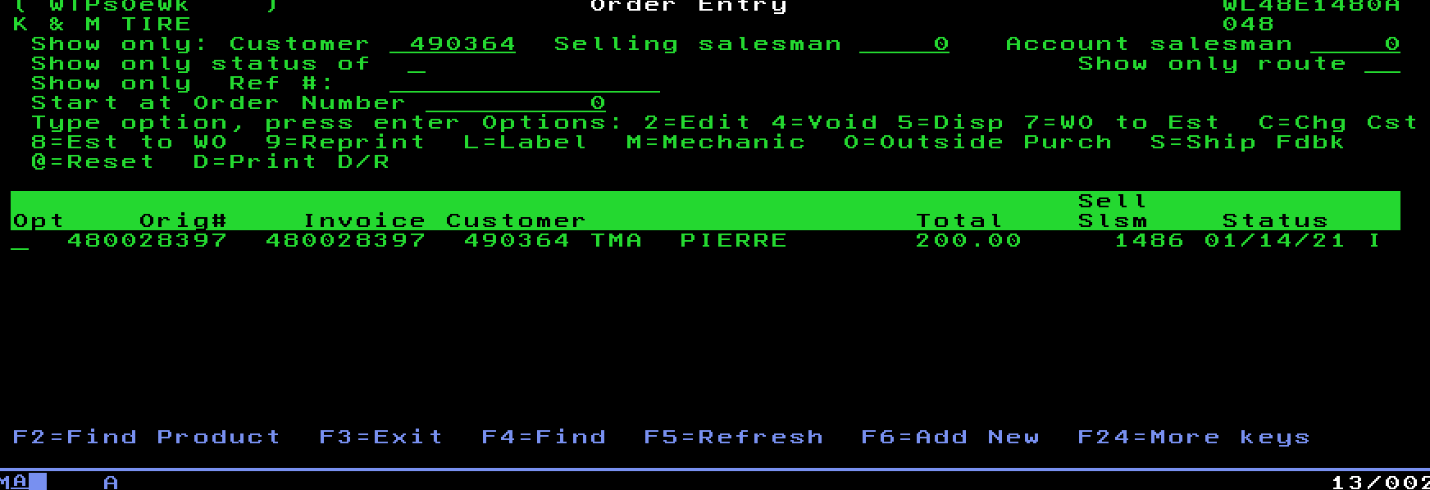

- Once this PO# is created it is used to order the product from the vendor for drop ship to customers.
- Then Accounts Payable receive the invoice and send the invoice to the BDM/Office Manager to be billed.
- BDM/Office Manager then bills the invoice sending back an email to A/P with Invoice#, Customer# and date.

Working with all vendors on monthly and quarterly specials.
- Vendors that we currently do quarterly specials with is Vendor#252, 895, 275, 271 &254.
- See 5.2 for all vendor contact info.

Enhancing organization reputation by accepting ownership for accomplishing new and different opportunities on tire supplies / equipment items.
- Stay up to date on the market with tire supplies.
- Look into new vendors and pricing.
- Have meetings with current vendors on trends/pricing.

Providing training, leadership & direction to tire supplies / equipment team to produce maximum GP.
- Key training from vendor websites on tire supplies/equipment/tire manufactures.
- Understand all the programs that K&M has to offer the customer.
- Provide any product/PDF documents the team needs.
- Provide all quarterly specials and discuss with direction on the special.

Keep outside sales staff updated with monthly sales flyers and promotions on tire supplies / equipment.
- Email the outside sales staff flyers/product updates/sales spiff info. Email: outsidesales@kmtire.com

Submit monthly communication report to Admin Department, VP of Sales and Director of Sales.
- Monthly report should include the following sections:
- Sales report for tire supply/equipment division
- Any updates with vendors or product
- Any suggests on change with website or processes
- Goal updates
- Any updates with team members
- Summary of the previous month on accomplishments or issues
- This report needs to be submitted by the 10th of every month

Submit and approve time cards / PTO / Reviews for the tire supply division in Paylocity.
- HR Dept. will get you setup on paylocity
- https://access.paylocity.com/

Work closely with K&M management
- Within the sales team it is vitally important that you have good working relationship with VP of Sales, Director of Sales, Marketing team, Commercial Sales manager, Ag Sales manager, Car Dealer sales manager, Inside Sales manager, All Regional Sales managers.

Must support company goals and playbook.
- Alignment with the direction the company is proceeding is key
- Ultimately, we all need to pull in the same direction
- Promote this effort with the tire supply/equipment division

Frequently Asked Questions
K&M instructions: Provide information on how the Warehouse Manager can get emergency assistance and system support (e.g., help desk support, inventory support, etc.). Include the names of the responsible personnel and organization(s), telephone numbers, and email addresses of the staff who serve as points of contact for system support.

Table 1 - Support Points of Contact
Contact / | Department | Phone | Email | Role
K&M Corporate Line | Corporate | 419-695-1061 | n/a

Other
    - other

Appendix A: Miscellaneous
Add links here

Appendix B: Supportive Department Summaries
How we can help at the field level?
Inventory Specialist:
Sales Department:
Purchasing Department:
Credit Department:

Instructions: Provide a list of acronyms and associated literal translations used within the document. List the acronyms in alphabetical order using a tabular format as depicted below.

Table 2 - Acronyms
Acronym | Literal Translation
<Acronym> | <Literal Translation>

Appendix C: Glossary
Instructions: Provide clear and concise definitions for terms used in this document that may be unfamiliar to readers of the document. Terms are to be listed in alphabetical order.
Table 3 - Glossary
Term | Acronym | Definition
Appendix D: Referenced Documents

Table 4 - Referenced Documents
Document Name | Document Location and/or URL | Issuance Date
Appendix E: Approvals
The undersigned acknowledge that they have reviewed the User Manual and agree with the information presented within this document. Changes to this User Manual will be coordinated with, and approved by, the undersigned, or their designated representatives.
Instructions: List the individuals whose signatures are desired. Examples of such individuals are Business Owner, Project Manager (if identified), and any appropriate stakeholders. Add additional lines for signature as necessary.
Table 5 - Approvals
Document Approved By | Date Approved
Name: <Name>, <Job Title> - <Company> | Date
Name: <Name>, <Job Title> - <Company> | Date
Name: <Name>, <Job Title> - <Company> | Date
Name: <Name>, <Job Title> - <Company> | Date
Appendix F: Additional Appendices
K&M Usage: Utilize additional appendices to include additional data, charts, etc..

Appendix G: Notes to the Author/Template Instructions
This document is a template for creating a User Manual for a given investment or project. The final document should be delivered in an electronically searchable format. The User Manual should stand on its own with all elements explained and acronyms spelled out for reader/reviewers, including reviewers outside CMS who may not be familiar with CMS projects and investments.
This template includes instructions, boilerplate text, and fields. The developer should note that:
- Each section provides instructions or describes the intent, assumptions, and context for content included in that section. Instructional text appears in blue italicized font throughout this template.
- Instructional text in each section should be replaced with information specific to the particular investment.
- Some text and tables are provided as boilerplate examples of wording and formats that may be used or modified as appropriate.
When using this template, follow these steps:
- Table captions and descriptions are to be placed left-aligned, above the table.
- Modify any boilerplate text, as appropriate, to your specific investment.
- Do not delete any headings. If the heading is not applicable to the investment, enter “Not Applicable” under the heading.
- All documents must be compliant with Section 508 requirements.
- Figure captions and descriptions are to be placed left-aligned, below the figure. All figures must have an associated tag providing appropriate alternative text for Section 508 compliance.
- Delete this “Notes to the Author/Template Instructions” page and all instructions to the author before finalizing the initial draft of the document.
Appendix H: Revision History Tracking
The following table records information regarding changes made to the Operations Binder.

Table 6 - Revision History Tracking
Version Number | Date | Author/Owner | Description of Change

